II B.Tech I Semester Regular Examinations - November, 2025
DATABASE MANAGEMENT SYSTEMS
(CSE)
Time: 150 Min Max. Marks:60M
SECTION – A
Answer all Four questions 4X8M=32M

1. | VCH Stores is a regional retailer that manages thousands of daily transactions across multiple branches. Until recently, they recorded all sales and customer details in traditional paper ledgers and Excel sheets. To improve data reliability and reduce redundancy, the management plans to migrate to a Database Management System (DBMS). The system must store details of customers, orders, order items, and products as shown in the ERdiagram provided:  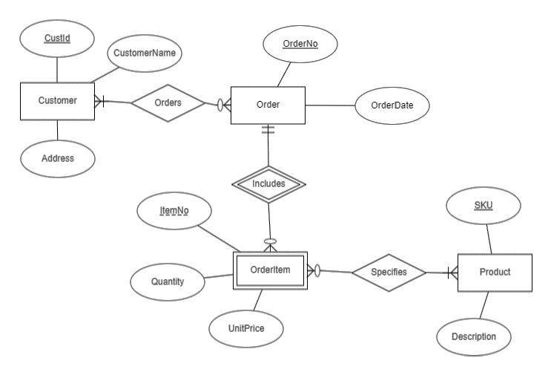
a) | Why Database Management System (DBMS) is preferred over traditional file processing systems for VCH Stores. | [2M]
b) | Using the given ER diagram as a reference, apply ER modeling concepts to describe how VCH Stores’ data would be structured in a real database.  - Classify the entities as strong or weak and specify their primary keys.  ii.Determine the relationship types with appropriate cardinalities and participation constraints. | [4M]
c) | Analyze the ER model and suggest any two improvements or refinements to make it more efficient or realistic for VCH Stores’ database design. | [2M]
2. | The University Student Records Department maintains a database to store information about students’ identities, academic details, and course enrollments. Initially, the department keeps student data such as student ID, name, login, age, and GPA in a single table named STUDENT. A few sample records are shown below:  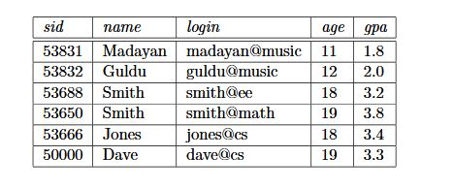
a) | Based on the given table:  i) Identify fields, records and instances.  ii) Determine the degree and cardinality of the given relation. | [2M]
b) | The Records Department intends to implement the Student Information System using SQL. Utilize your understanding of Data Definition Language (DDL) to design and construct the database schema by executing the following tasks in a logical sequence  i. CREATE TABLE with constraints (Primary Key, Unique, Check).  ii. Extend the table by adding a new column address  iii. Modify the table structure by renaming the column login to mail to reflect updated  database standards. | [3M]
c) | The university management now requires the database to track student registrations for courses. Analyze the existing STUDENT schema and perform the following tasks in sequence:  i. Determine the logical relationship exist between the STUDENT table and a new table  storing course registration details.  ii. Formulate an SQL query to retrieve each student’s name along with the course(s)  registered, based on the relationship established between the two tables. | [3M]
3. | An insurance department maintains details of employees having insurance policies and their dependents. The following ER diagram represents the relationships among the entities Employees, Policies, and Dependents.  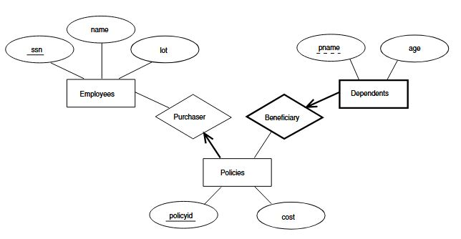
a) | Interpret the given ER diagram and identify:  i. The entities and their attributes.  ii.The types of relationships shown between them | [2M]
b) | Convert the ER diagram into an appropriate relational schema, specifying:  i. Table names and attributes  ii. Primary keys and foreign keys | [3M]
c) | Based on your relational schema, develop relational algebra expressions to retrieve:  i. Names of employees who purchased policies costing more than 10,000.  ii. Names of dependents who benefit from a particular employee’s policy.  iii. Employee(s) with the highest-cost policy. | [3M]
4. | A scheduled Bank operates a centralized database that handles multiple customer accounts and concurrent transactions. On a busy day, several transactions occur at the same time for example:  T1: Transfers ₹5,000 from Account A to Account B.  T2: Deposits ₹3,000 into Account A.  T3: Withdraws ₹2,000 from Account B.
a) | To guarantee data integrity and consistency, the bank’s transaction system must comply with the ACID properties of database transactions. Explain each ACID property and discuss its importance in ensuring reliable and fault-tolerant transaction processing. | [2M]
b) | During simultaneous processing, the following two transactions access the same data item A:  T1: Read(A); A = A - 1000; Write(A);  T2: Read(A); A = A + 500; Write(A);  Apply your knowledge of transaction scheduling to construct a possible interleaved schedule for these transactions and determine whether it represents a serial or non-serial schedule, providing appropriate justification. | [3M]
c) | In the context of the above scenario, evaluate the following concurrent transaction schedules involving data items A and B. Determine whether each schedule is conflict-serializable or non-serializable, and justify your conclusion using an appropriate precedence graph.  Schedule S1  T1: Read(A); Write(A); Read(B); Write(B);  T2: Read(A); Write(A); Read(B); Write(B);  Schedule S2  T1: Read(A); Read(B); Write(A);  T2: Read(B); Write(B); Write(A); | [3M]

SECTION - B
Answer all Two questions 2X14M=28M

5. | The Zomato Company stores data about its employees, their work locations, and weekly wages in the following table:  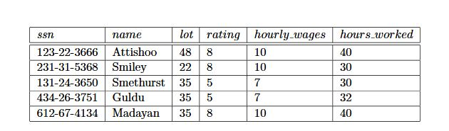
a) | Identify and describe the possible anomalies that may occur in the given table.  For each anomaly:  - Specify the situation or data condition where it occurs.  ii. Justify how that situation reflects the presence of the anomaly (using examples from  the table). | [3M]
b) | The following functional dependencies (FDs) are observed in the table:  $$\text{FD1: }ssn→name,lot,rating,hourly_wages,hours_worked \\ \text{FD2: }rating→hourly_wages$$  Apply normalization principles to decompose the given relation into Third Normal Form. Perform the following tasks:  i. Derive the intermediate relations during the 1NF → 2NF → 3NF conversion process.  ii. Determine the candidate key(s) at each stage of decomposition.  iii. Construct the final 3NF relations that remove the anomalies observed in part (a). | [5M]
c) | Analyze the normalized relations obtained in part (b).  i. Evaluate whether any redundancy or dependency preservation issues persist in the current design.  ii. Assess how effectively the decomposition maintains data consistency during  insertions and updates.  iii. Provide recommendations on whether the design requires further optimization, such as conversion to Boyce–Codd Normal Form (BCNF), to enhance overall efficiency and integrity. | [6M]
6. | The Dane County Airport Authority wants to organize all information about its airplanes, technicians, and maintenance activities using a DBMS.  The following details are available:  - Each airplane has a registration number and belongs to a specific model.  - Each model has a model number, capacity, and weight.  - Each technician has a name, SSN, address, phone, and salary.  - Each technician is an expert on one or more airplane models.  - Traffic controllers undergo an annual medical examination, and the most recent exam date must be stored.  - All airport employees (including technicians and controllers) have a union membership number and are uniquely identified by SSN.  - Each FAA test has a test number, name, and maximum possible score.  - For each testing event, the airport records the airplane tested, technician who performed it, the test applied, the date, hours spent, and score obtained.
a) | Identify and describe the key entities, attributes, and relationships present in the above scenario | [3M]
b) | Building on part (a), design an Entity–Relationship (ER) diagram for the airport database system.  Your design should include:  i. Entities and attributes  ii. Relationships and cardinalities  iii. Keys and participation constraints  Subsequently, convert the ER diagram into a relational schema, clearly specifying primary keys and foreign keys. | [4M]
c) | Using the relational schema derived in part (b), formulate SQL queries to analyze the stored data:  i. Retrieve the names of technicians who have tested more than one airplane.  ii. List each airplane’s registration number with its average test score.  iii. Create a view called Technician Expertise View that displays each technician’s name, SSN, and the models they are experts in. | [4M]
d) | Examine the relational schema derived in part (b) and evaluate whether it satisfies Third Normal Form (3NF).  If it does not:  i. Identify the violations.  ii. Decompose the affected relations to achieve 3NF.  iii. Justify how the decomposition improves data consistency and reduces redundancy. | [3M]

